Topics: Descriptive Statistics and Probability

1. Look at the data given below. Plot the data, find the outliers and find out

|  |  |
| --- | --- |
| Name of company | Measure X |
| Allied Signal | 24.23% |
| Bankers Trust | 25.53% |
| GeneralMills | 25.41% |
| ITT | 24.14% |
| JPMorgan & Co | 29.62% |
| Lehman Brothers | 28.25% |
| Marriott | 25.81% |
| MCI | 24.39% |
| Merrill Lynch | 40.26% |
| Microsoft | 32.95% |
| Morgan Stanley | 91.36% |
| Sun Microsystems | 25.99% |
| Travelers | 39. 42% |
| US Airways | 26.71% |
| Warner-Lambert | 35.00% |
|  |  |

**A)**

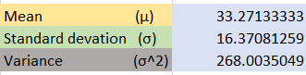

Outliers**: - Morgan Stanley 91.36**

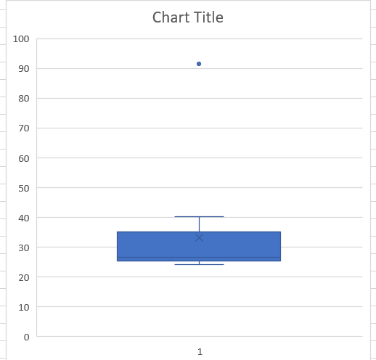



Answer the following three questions based on the box-plot above.

1. What is inter-quartile range of this dataset? (Please approximate the numbers) In one line, explain what this value implies.

**A)**  Q1 = 5 (approximately), Q3 = 12 (approximately)

Inter-quartile range (IQR) = Q3 – Q1 = 12 – 5 = **7**

1. What can we say about the skewness of this dataset?
2. **Symmetrically Distributed**
3. If it was found that the data point with the value 25 is actually 2.5, how would the new box-plot be affected?
4. **The value 25 is an outlier it changes to 2.5 then the outlier will change & skewness also gets change**



Answer the following three questions based on the histogram above.

(i)Where would the mode of this dataset lie?

**A)** **More data lies between 4 to 8**

(ii)Comment on the skewness of the dataset.

**A) Positive skewed**

(iii) Suppose that the above histogram and the box-plot in question 2 are plotted for the same

dataset. Explain how these graphs complement each other in providing information about

any dataset.

**A) They both are right-skewed and both have outliers the median can be easily visualization in**

**box plot where as in histogram model is more visible**

4. AT&T was running commercials in 1990 aimed at luring back customers who had switched to one of the other long-distance phone service providers. One such commercial shows a businessman trying to reach Phoenix and mistakenly getting Fiji, where a half-naked native on a beach responds incomprehensibly in Polynesian. When asked about this advertisement, AT&T admitted that the portrayed incident did not actually take place but added that this was an enactment of something that “could happen.” Suppose that one in 200 long-distance telephone calls is misdirected. What is the probability that at least one in five attempted telephone calls reaches the wrong number? (Assume independence of attempts.)

**A)** Suppose that one in 200 long-distance telephone calls is misdirected

P **(**callmisdirecting**) =** 1/200

      Probability of call not Misdirecting(q) = 1 - 1/200 = 0.995

Number attempted of Calls = 5

n = 5

p = 1/200

q = 199/200

P(X) = nCx px qn-x

at least one in five attempted telephone calls reaches the wrong number

= 1 - none of the call reaches the wrong number

= 1 - P (0)

= 1 - 5Co (1/200)0(199/200) ⁵⁻⁰

= 1 - (199/200) ⁵

= 0.02475

* **P (At least one in five attempted telephone calls reaches the wrong number) = 0.02475**

1. Returns on a certain business venture, to the nearest $1,000, are known to follow the following probability distribution

|  |  |
| --- | --- |
| X | P(x) |
| -2,000 | 0.1 |
| -1,000 | 0.1 |
| 0 | 0.2 |
| 1000 | 0.2 |
| 2000 | 0.3 |
| 3000 | 0.1 |

|  |  |  |  |
| --- | --- | --- | --- |
| (X) | P(X) | E(X)=X. P(X) | E(X²) =X².P(X) |
| -2000 | 0.1 | -200 | 400000 |
| -1000 | 0.1 | -100 | 100000 |
| 0 | 0.2 | 0 | 0 |
| 1000 | 0.2 | 200 | 200000 |
| 2000 | 0.3 | 600 | 1200000 |
| 3000 | 0.1 | 300 | 900000 |
|  | **∑E(XP(X)** | **800** | 2800000 |

(i) What is the most likely monetary outcome of the business venture?

**A) Most likely monetary outcome of the business venture is 2000$ and its probability**

**Maximum is 0.3**

(ii) Is the venture likely to be successful? Explain

**A) venture is likely to be successful if x is + ve**

Hence positive values of X are 1000,2000 or 3000

Probability is 0.2 + 0.3 + 0.1 = 0.6

as 0.6 > 0.5 Hence **venture likely to be successful**

(iii) What is the long-term average earning of business ventures of this kind? Explain

**A) long-term average earning of business ventures = 800$**

(iv) What is the good measure of the risk involved in a venture of this kind? Compute

this Measure

**A)** Risk involved in a venture

Variance(X) = E(X²) - {E(X)} ²

= 2800000 – 800 ²

= **2160000** (Quite High)

Standard deviation = √Var = **$ 1470**

As **Variability is Quite high** hence **Risk is high**